

St. Richard’s Catholic Primary School
Long Term Plan
Year 1 2026- 2025

 | Autumn 1 | Autumn 2 | Spring 1 | Spring 2 | Summer 1 | Summer 2
Title | What will we find in the woods? |  | What is the difference between the past and the present? |  | How have explorers changed the world?
Project Hook/ Trip | Trip to Wildwood |  | Dover Museum | Transport museum |  | Trip to the beach
English | Gruffalo –Character description  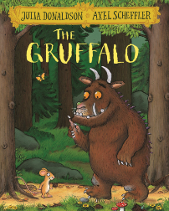  Recount of trip | Stick Man - Narrative  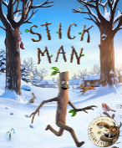  Christmas poems | 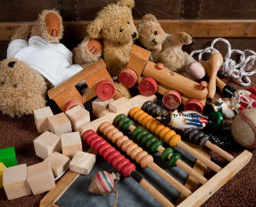  Non-chronological reports old and new toys | Old Bear – Diary writing  Easter/ Spring poems  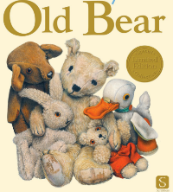 | Meerkat mail – letters 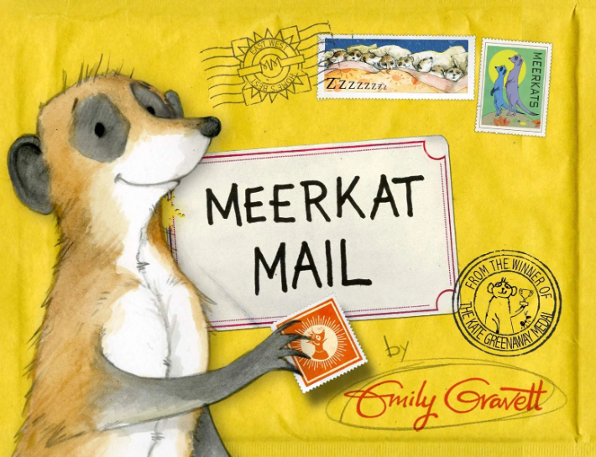  Biography of an explorer | 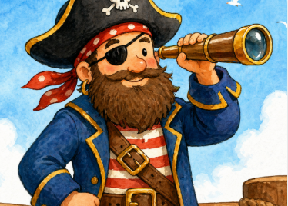  Treasure of Pirate Tom
Maths | Place Value (within 10)  Addition and Subtraction (within 10) | Addition and Subtraction (within  10)  Geometry (shape) | Place Value (Within 20)  Addition and Subtraction (within  20) | Place Value (Within 50)  Measurement: Length and height, mass, volume | Fractions  Multiplication and division  Geometry (position and direction) | Place Value (Within 100) Measurement (money and time)
Religious Education | Lighting the path | Lighting the path | Lighting the path | Lighting the path | Lighting the path | Lighting the path
Science | Seasonal Changes  Animals including humans | Seasonal Changes  Animals including humans | Seasonal Changes  Everyday materials | Seasonal Changes  Everyday materials | Seasonal Changes  Plants | Seasonal Changes  Plants
Computing | Computing systems and networks – Technology around us | Creating media – Digital painting | Programming A – Moving a robot | -Data and information | Creating Media digital writing | Programming B – Programming animations
History |  |  | Changes within living memory (What was life like when our grandparents were young?)  Lives of significant people (Christopher Columbus)  (What is an explorer?) | Historical events within local area  (How has Dover changed?)
Geography | Compass points  Ariel photographs  Maps | Natural and physical features  Identify seasonal and daily weather patterns |  |  | Name and locate the seven continents and five oceans  Name, locate and identify characteristics of the four countries and capital cities of the UK | Maps and atlas’  Beach fieldwork
Design Technology |  |  | Textiles- Make a doll using a running stitch | Mechanism- Wheels and axels make a moving vehicle |  | Food Technology  Design and make a healthy lunch
Art | Natural materials art (Printing) | Natural materials art (Weaving) |  |  | Sculpture  Using clay
Music | Keeping the pulse (my favourite things) | Tempo (snail and mouse)
Physical Education | Gymnastics:  Movement and Balance | Dance:  My moves, my body | Health and wellbeing: the effects of exercise | Ball skills  Sending, receiving and dribbling | Outdoor adventurous activities: working with others | Ball skills: pushing and striking
PSHE | Health and wellbeing: healthy lifestyles | Relationships: families; friendships; managing hurtful behaviour; respecting self and  others | Health and well being  Physical health | Health and well being  Mental Health | Living in the wider world  Connection | Living in the wider world  Community

